**Planning & Scheduling – Assignment 1**

Michael McAleer – R00143621

**Part 1 – The Wolf, Goat, and Cabbage – State-Transition Systems**

**Legend:**

Farmer (F) Wolf (W) Goat (G) Cabbage (C)

**State Space**

The problem initial state is [FWGC |], meaning the farmer, wolf, goat and cabbage are all on the West side of the river.

The goal state is to have the farmer, wolf, goat, and cabbage on the East side of the river as represented by [| FWGC].

There are several invalid states that can be encountered whilst finding a sequence of moves from the initial state to the goal state:

* The wolf cannot be left alone with the goat [WG | FC] [FC | WG] [WGC | F] [F | WGC]
* The goat cannot be left alone with the cabbage [GC | FW] [FW | GC]

There are four possible actions:

* The farmer crosses with the wolf
* The farmer crosses with the goat
* The farmer crosses with the cabbage
* The farmer crosses alone

**Solution:**

* 10 possible valid world states
* 2 optimal solutions

|  |  |  |  |  |
| --- | --- | --- | --- | --- |
| **Solution 1** | |  | **Solution 2** | |
| **West** | **East** |  | **West** | **East** |
| FWCG | - |  | FWGC | - |
| WC | FG |  | WC | FG |
| FWC | G |  | FWC | G |
| W | FCG |  | C | FWG |
| FWG | C |  | FGC | W |
| G | FWC |  | G | FWC |
| FG | WC |  | FG | WC |
| - | FGWC |  | - | FWGC |

**State Transition Diagram**

The start state is the green node on the left, the goal state is the green node on the right. Double-ended arrows are bi-directional, a red state indicates an illegal move where either the wolf is left with the goat, the goat is left with the cabbage, or both. The letters on the arrows indicate who/what is occupying the rowboat.

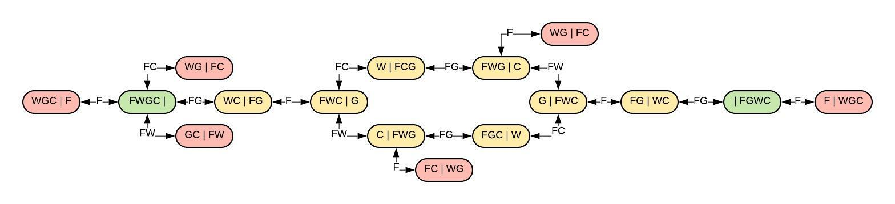

The two solutions can be used to create one complete state transition diagram, with the divergence in the diagram representing the various sequence of actions taken by both solutions. Both solutions revert to the same path after diverging to then reach the goal state.